Stream Biology Briefs
In aquatic ecosystems, scientists often categorize organisms by how they feed. This includes observation of the organisms in their habitat, and examining them under a microscope to investigate their morphology; the study of the form, structure and configuration of an organism. This includes aspects of the outward appearance (shape, structure, color, pattern) as well as the form and structure of the internal parts like bones and organs.

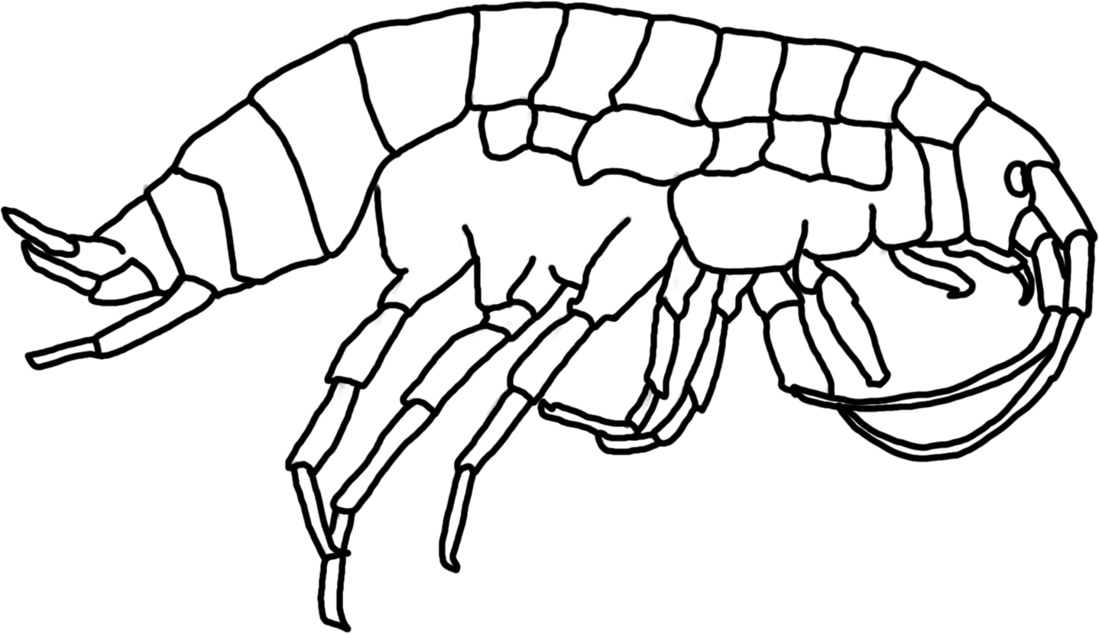
CLASSIFICATION BY FEEDING GROUP
Shredders: These animals take detritus, such as leaves, and break it into smaller particles or “skeletonize” it. Microbes colonize the leaf litter first, followed by the larger invertebrates such as the cranefly, some caddisflies & stoneflies, and amphipods (at left). The crane fly breaks down the leaves from the trees and makes the energy and nutrients in the leaves available to other aquatic organisms.

Collectors (both gathering and filtering): Some organisms are filter-feeders, spinning nets to catch fine particles of detritus. Others feed on detritus at the bottom of streams and ponds. These animals include the net-spinning caddisfly, blackfly larvae, midge larvae, clams, and some mayflies. Net-spinner caddisflies construct a mesh net for filter feeding, but this net is usually destroyed during collection. Black fly larvae and midge larvae have “fans” on their heads to capture material floating in the water. Some scientists separate out the scavengers from this group, but we will include scavengers.

Scrapers: Scrapers include animals that have mouthparts they can use to graze on hard surfaces such as rocks. They have to be strong to hold onto the surface while they feed. Many of these animals have a hard shell (such as the snail or water penny) to protect them from the high energy of the water. The water penny scrapes diatoms from the surface of rocks and then eats the material as it moves, since it is sheltered from the current by the hard plates. These animals include most snails, the water penny beetle, and some mayflies.

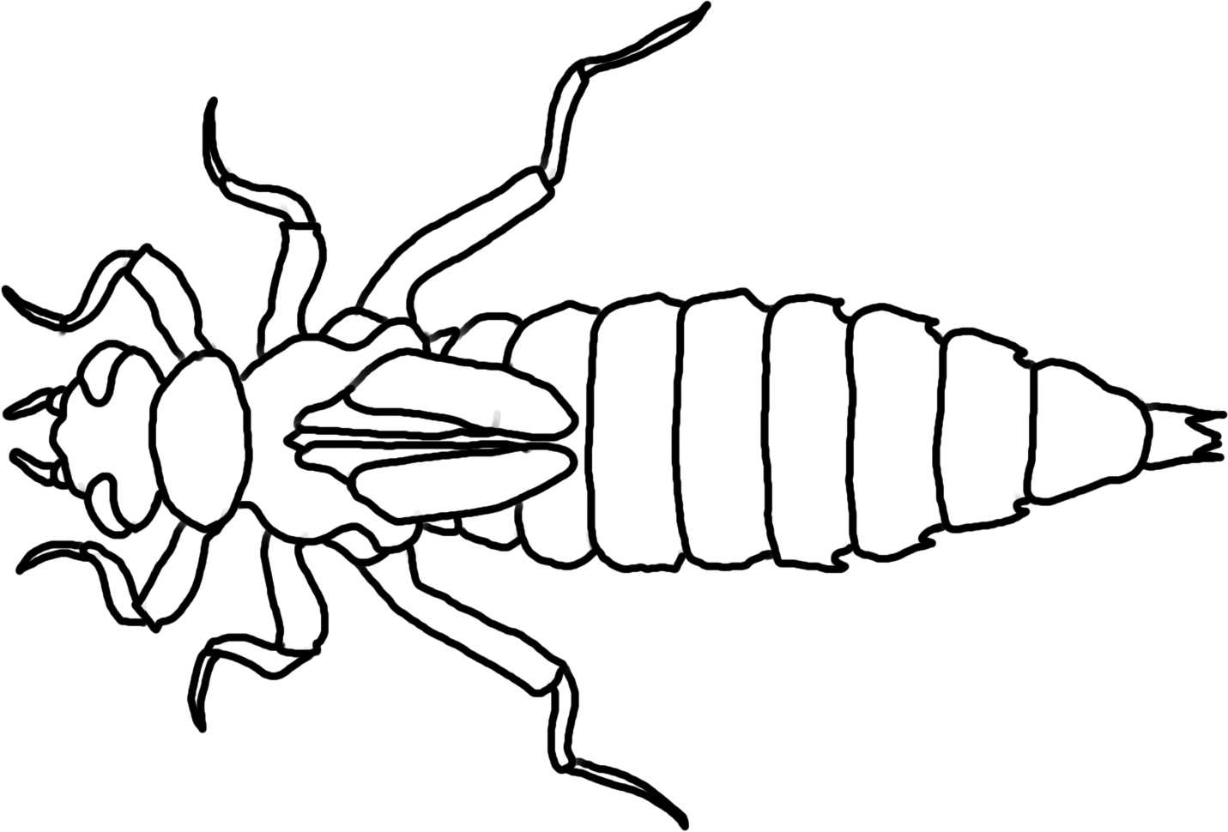
Predators: These animals have large mouthparts consisting of two opposing jaws which they use to kill other smaller invertebrates. Dragonflies (at right), damselflies, and the dobsonfly are part of this group. Dragonflies and damselflies have a large, extendable lower “lip” (labium) that can engulf very large prey, with mature dragonflies sometimes eating small fish. This lip covers the other mouthparts of the larvae, allowing it to capture large animals and tear pieces of their prey while still moving around on all six legs. Some scientists separate out parasites from this group, but we will include them here.
Decomposers: These organisms colonize leaf surfaces and use the leaves for food: microbes such as bacteria and fungi.
Producers: These organisms do photosynthesis. They make their own food, using sunlight to transform carbon dioxide and water into sugar plus oxygen. Producers include trees, diatoms, and algae.

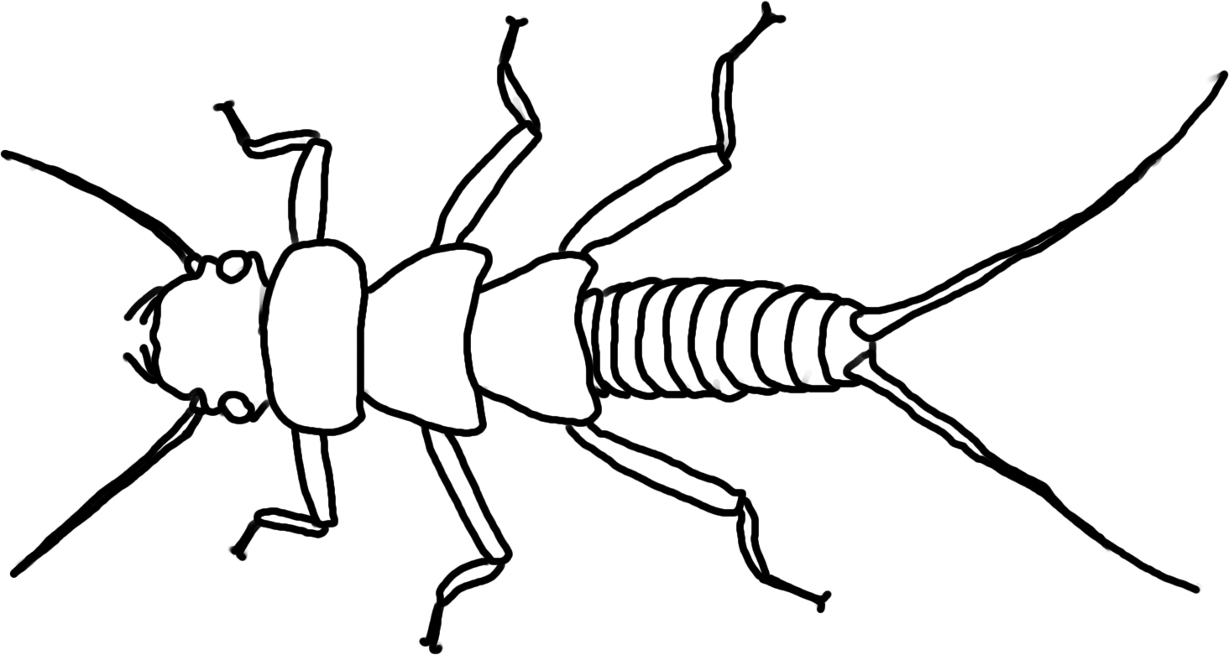
Stoneflies (Order Plecoptera)- Most stonefly are predators; some are shredders. Mouthparts determine whether they are shredders or predators. Shredder mouthparts are directed downward and are shaped for cutting and grinding, while predator mouthparts project forward and are very sharp and pointed. Common prey are midges and black flies along with mayflies. Lives in water with 8-12 mg/L of dissolved oxygen.
Dragonflies (Infraorder Anisoptera; order Odonata) – Predators of anything smaller-as young larvae they eat mostly zooplankton, and as they grow larger they will eat mayflies and even small fish. Lives in water with 4.1-7.9 mg/L of dissolved oxygen.
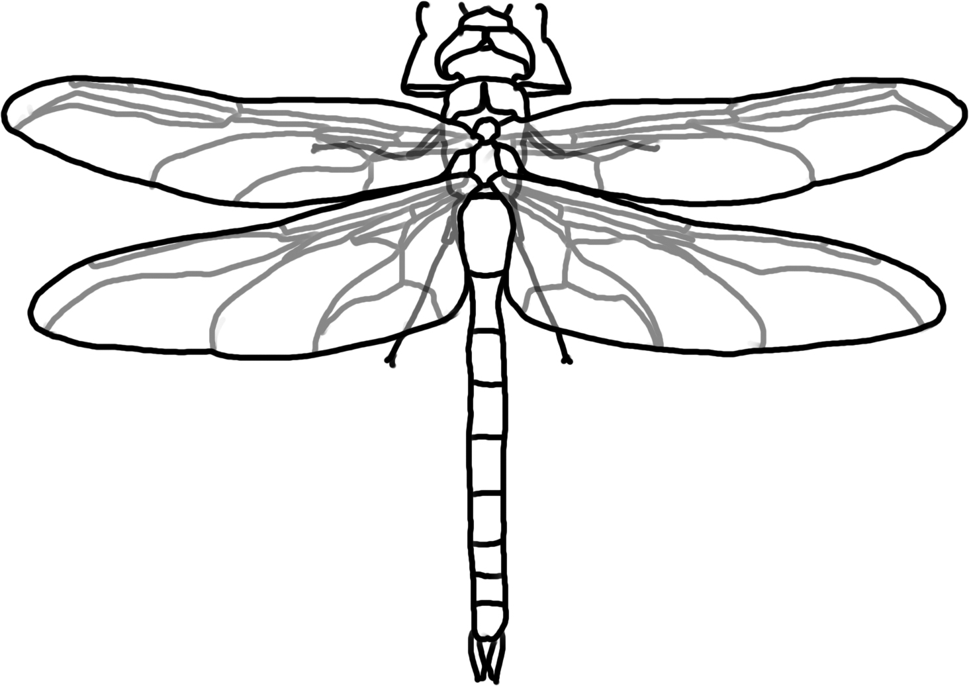

Damselflies (Suborder Zygoptera; order Odonata) – Aquatic nymphs hatch from eggs that are laid in the water. Many overwinter as nymphs, which crawl up on vegetation in the spring to emerge as adults. They are predators and live in water with 4.1-7.9 mg/L of dissolved oxygen.
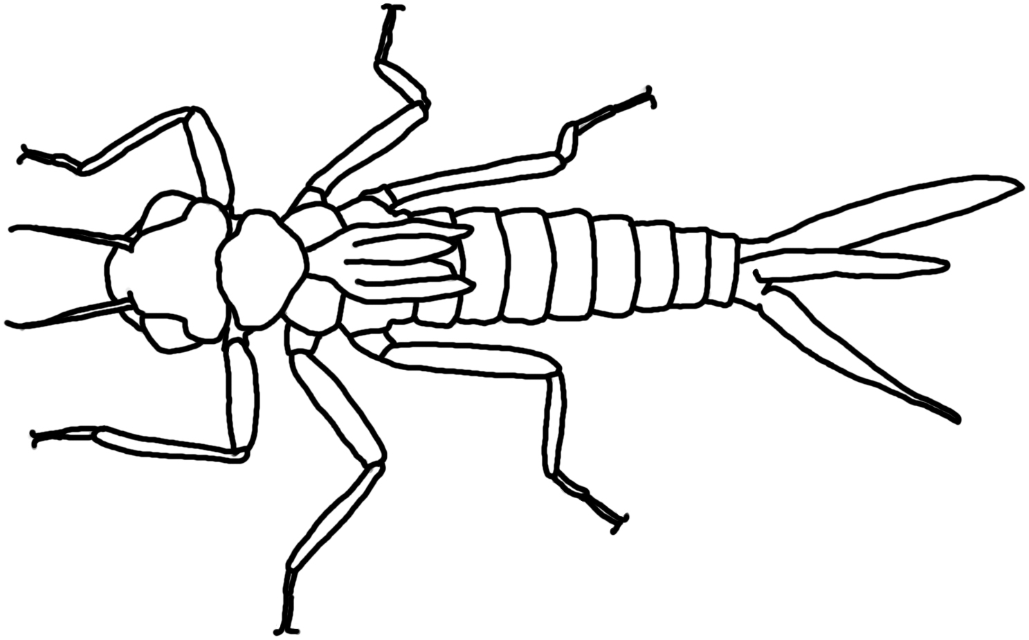
Mayflies (Order Ephemeroptera) – Overwinter as aquatic nymphs. Diet is mostly algae or detritus; mayflies are either collectors or scrapers (76% of the families are collectors, 19% are scrapers, and 5% are predators). Lives in water with 8-12 mg/L of dissolved oxygen.
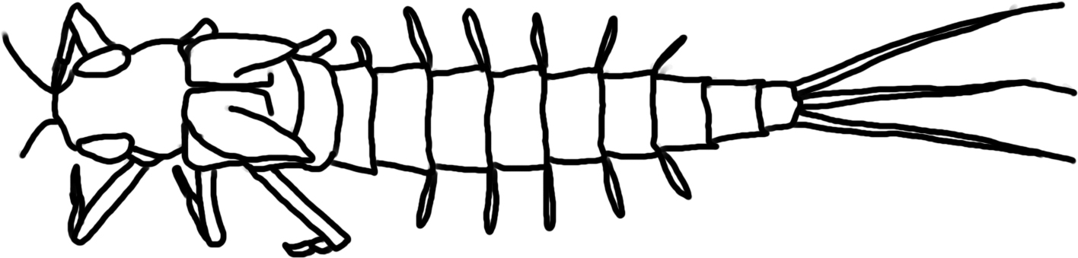
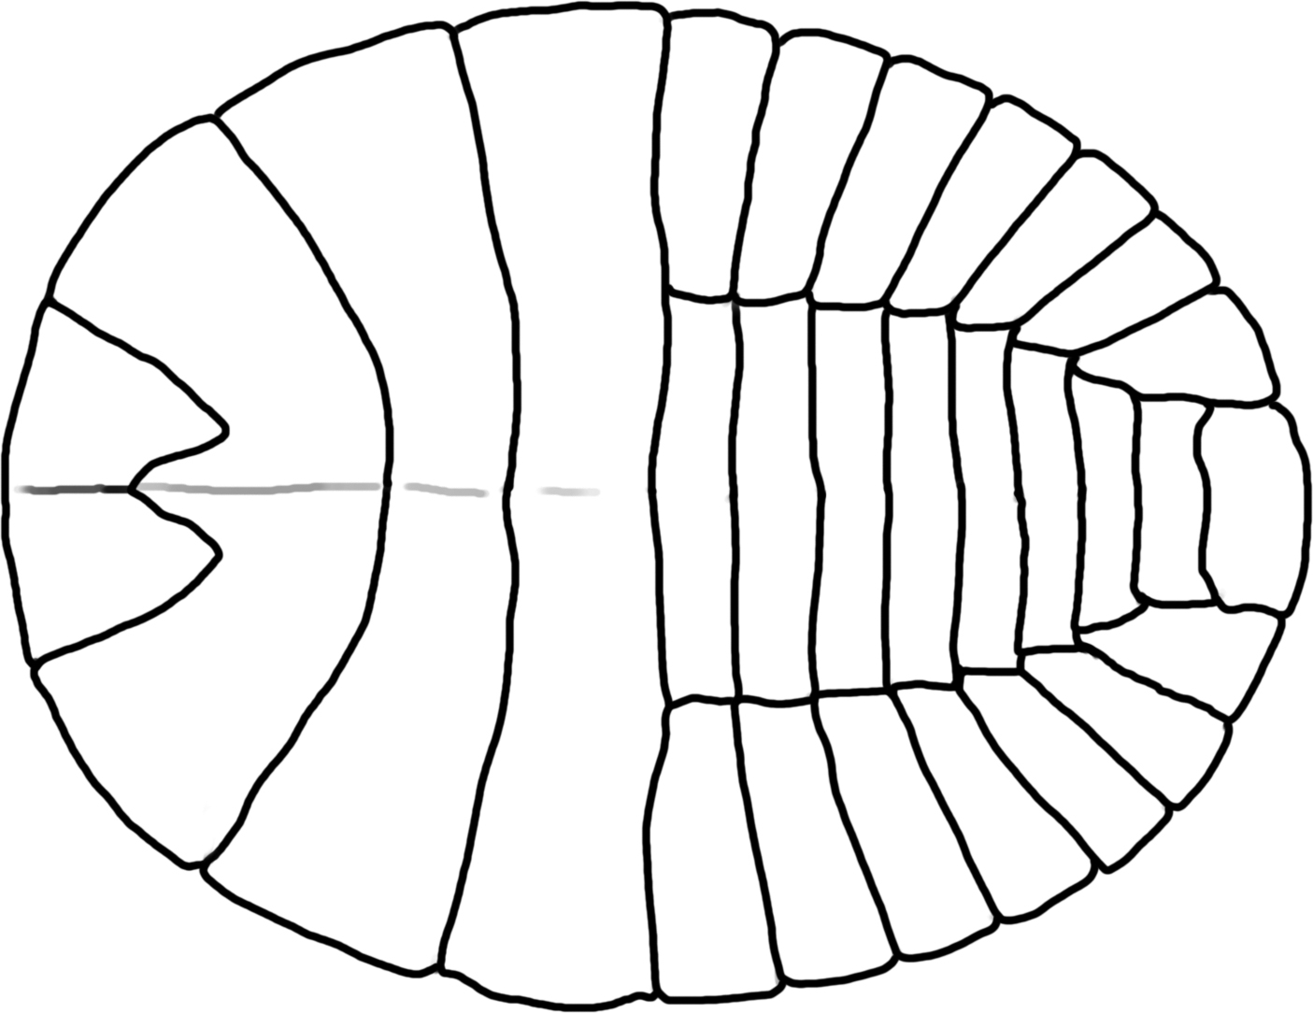
Water penny beetle (Order Coleoptera) – Flat shaped beetle that often curls up when disturbed, and has a strong grip to allow it to move across surfaces in highly turbid water. Water pennies are scrapers who graze on algae on rocks. Lives in water with 8-12 mg/L of dissolved oxygen.

Whirligig Beetles (Order Coleoptera) - Beetles that swim on the surface or underwater and are primarily collectors. Lives in water with 8-12 mg/L of dissolved oxygen.
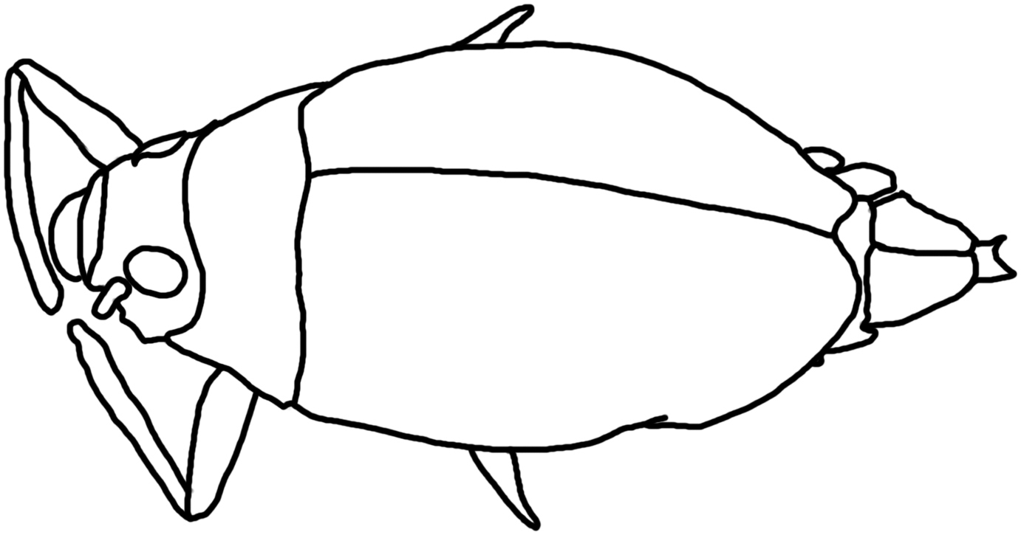
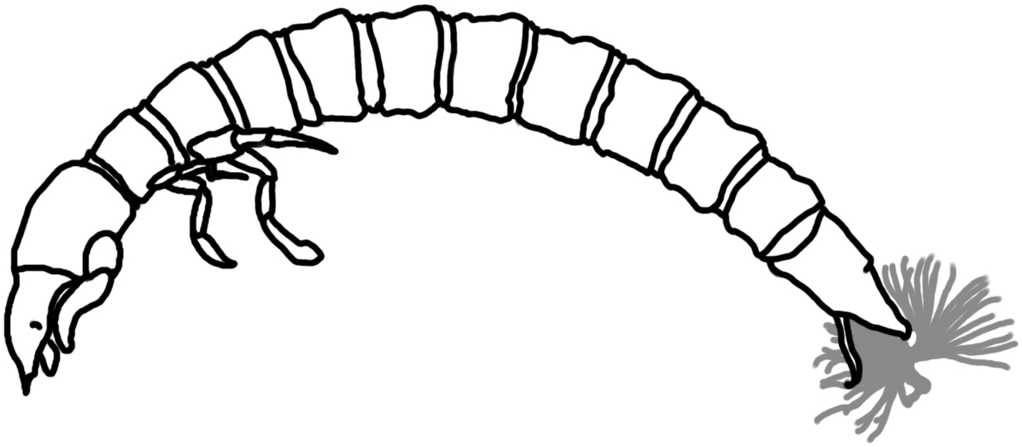
Riffle beetles (Order Coleoptera) – Small, torpedo-like larva with circular stripes or rings around the body, they are primarily collectors that eat diatoms and algae. Lives in water with 8-12 mg/L of dissolved oxygen.

Midge larvae (Family Chironomidae, Order Diptera)- Collectors that filter organic components of sediment & algae. Lives in water with less than 4.0 mg/L of dissolved oxygen.

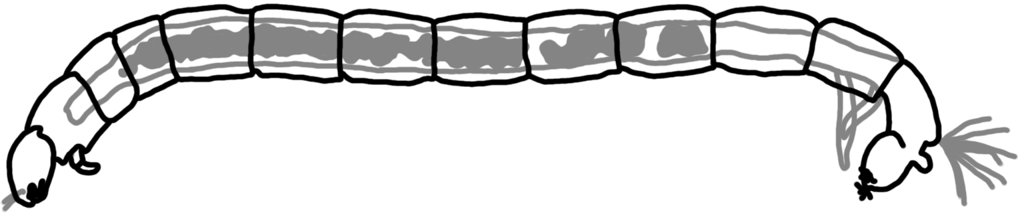
Blackfly larvae (Family Simuliidae, Order Diptera)- Collectors; they hold onto the substrate with tiny hooks and then extend a foldable “fan” into the stream, filtering particles of food (bacteria, detritus, algae) into the fan which is then scraped into its mouth every few seconds. Larvae are very small – between 3 and 12 mm long. Lives in water with less than 4.0 mg/L of dissolved oxygen.
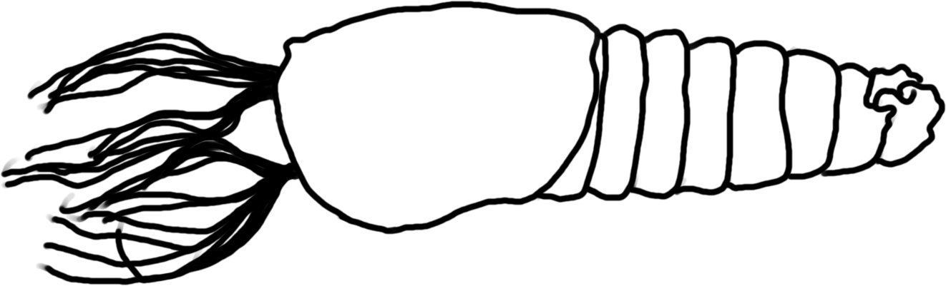
Crane Fly Larvae (Family Tipulidae, Order Diptera)- shredders; break down leaves from trees. Crane fly larvae often look like large worms or maggots, and can be up to 2” long (10-100mm). (Crane fly from genus Hexatoma are engulfer-predators.) Lives in water with 4.1-7.9 mg/L of dissolved oxygen.
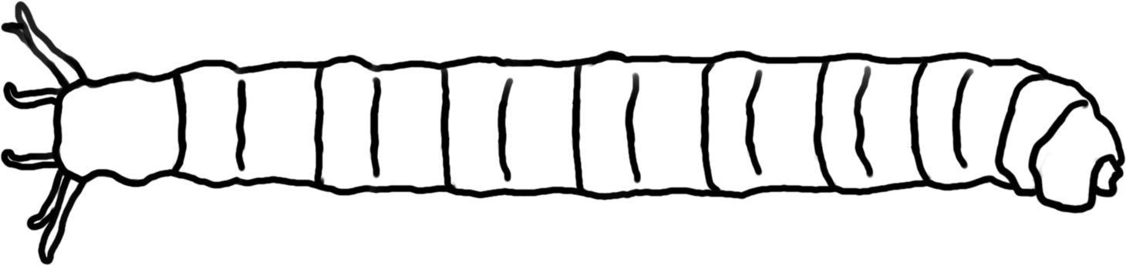
Dobsonfly larvae (also called Hellgrammite; Subfamily Corydalidae, Order Megaloptera)- Predators of any small invertebrate. Lives in water with 4.1-7.9 mg/L of dissolved oxygen.
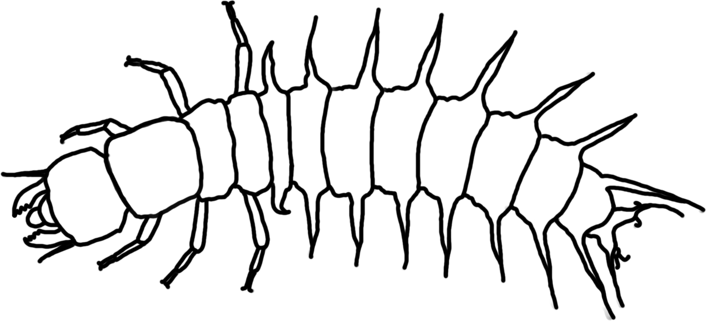
Alderflies (Order Megaloptera) – Aquatic larvae are active predators that feed on aquatic insects, worms, crustaceans, snails and clams. All are predators. Lives in water with 4.1-7.9 mg/L of dissolved oxygen.
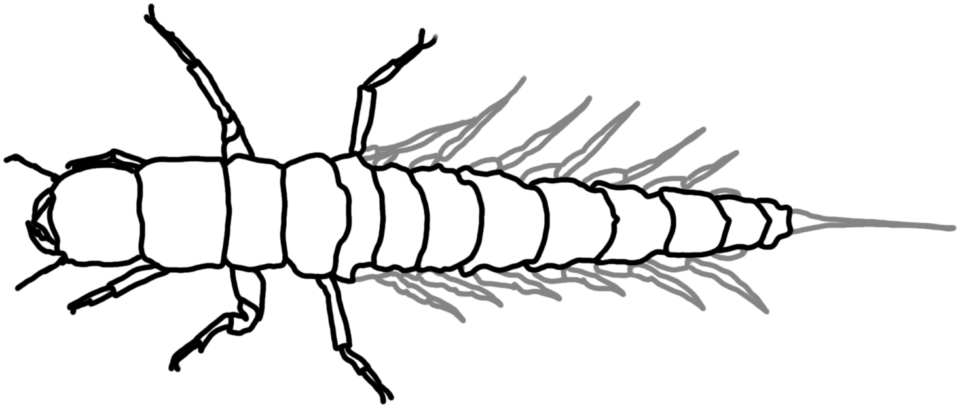
Caddisfly larvae- case makers (Order Trichoptera)- most caddisflies that construct cases of small stones are shredders of detritus and algae. Lives in water with 8-12 mg/L of dissolved oxygen.

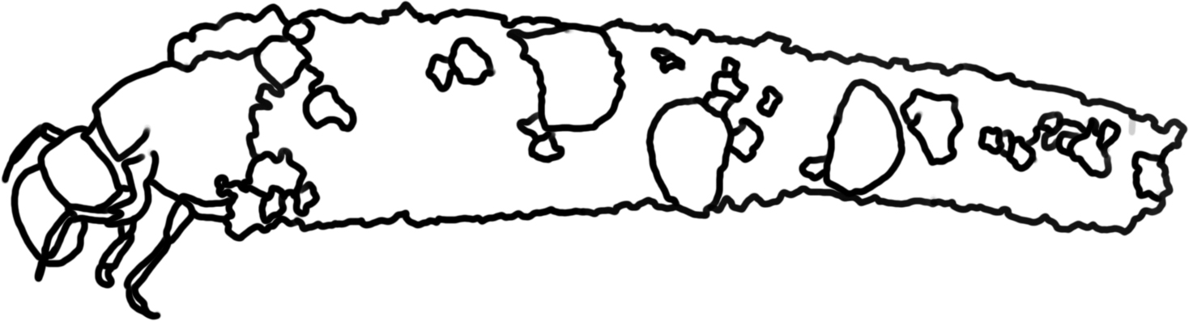
Free-living Caddisflies (Order Trichoptera)- are mostly predators of smaller invertebrates or scavengers. Lives in water with 8-12 mg/L of dissolved oxygen.
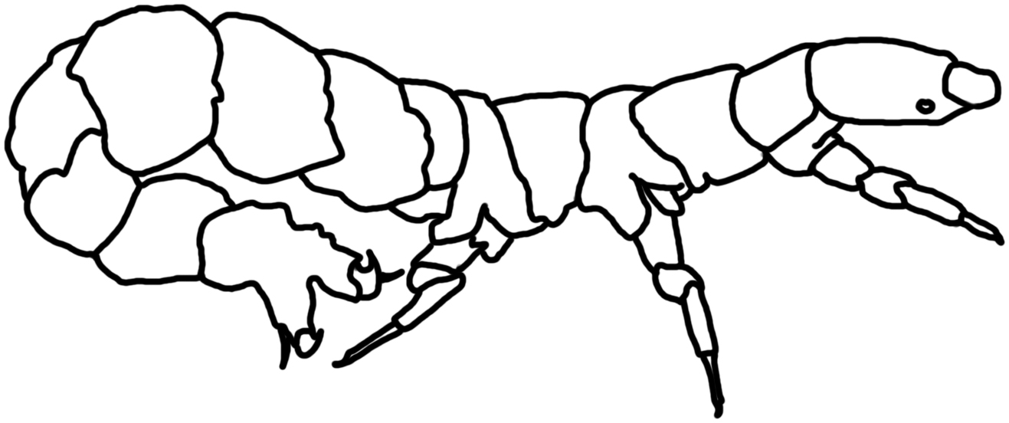
Net spinner Caddisfly (Order Trichoptera; Family Hydropsychidae) – Collectors who spin nets to catch fine particles of detritus. Lives in water with 4.1-7.9 mg/L of dissolved oxygen.
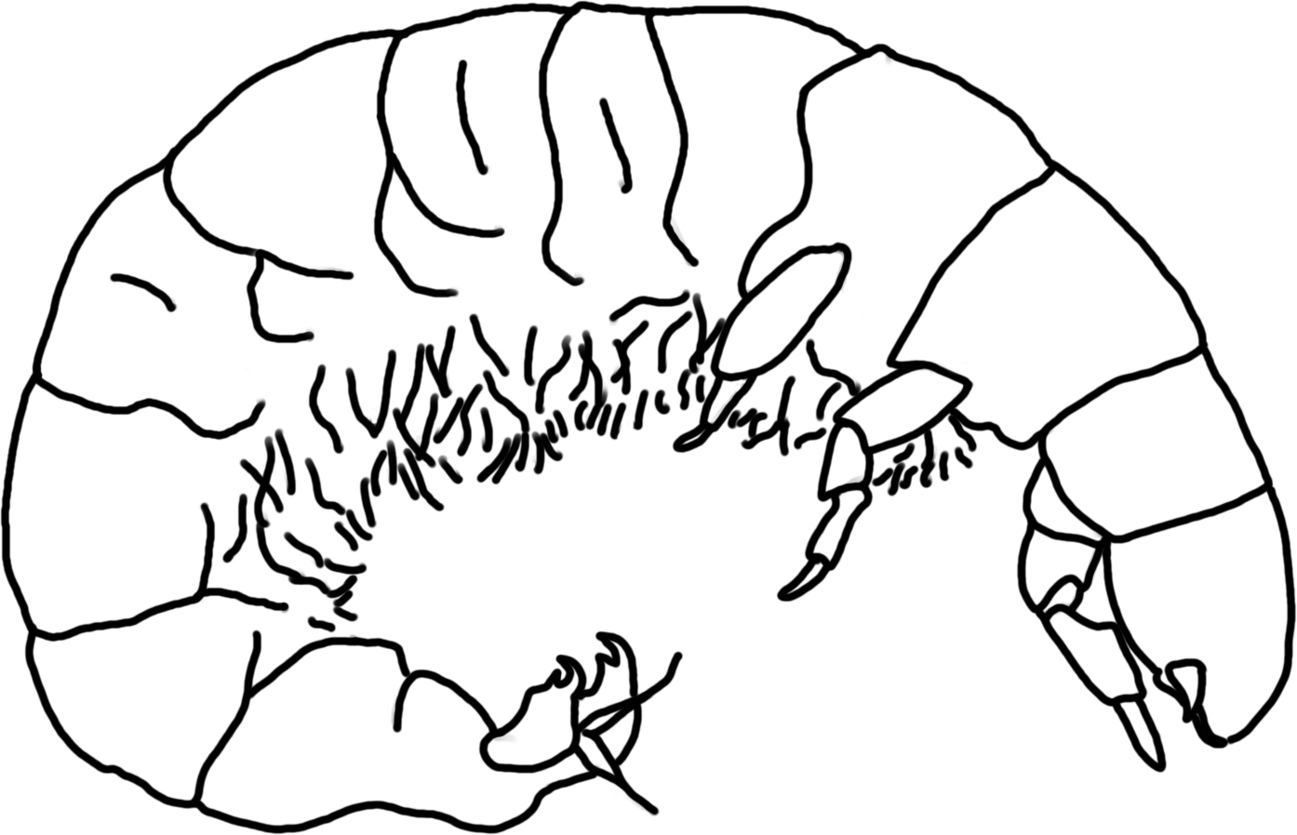
Scud (Order Amphipoda; also called sideswimmers and amphipods)- Shredders who eat mostly detritus, algae, bacteria, and any recently dead organisms. Lives in water with 4.1-7.9 mg/L of dissolved oxygen.
Sowbugs/Pill bugs (Order Isopoda) – Eat a variety of decaying organic matter. Most are collectors. Lives in water with 4.1-7.9 mg/L of dissolved oxygen.
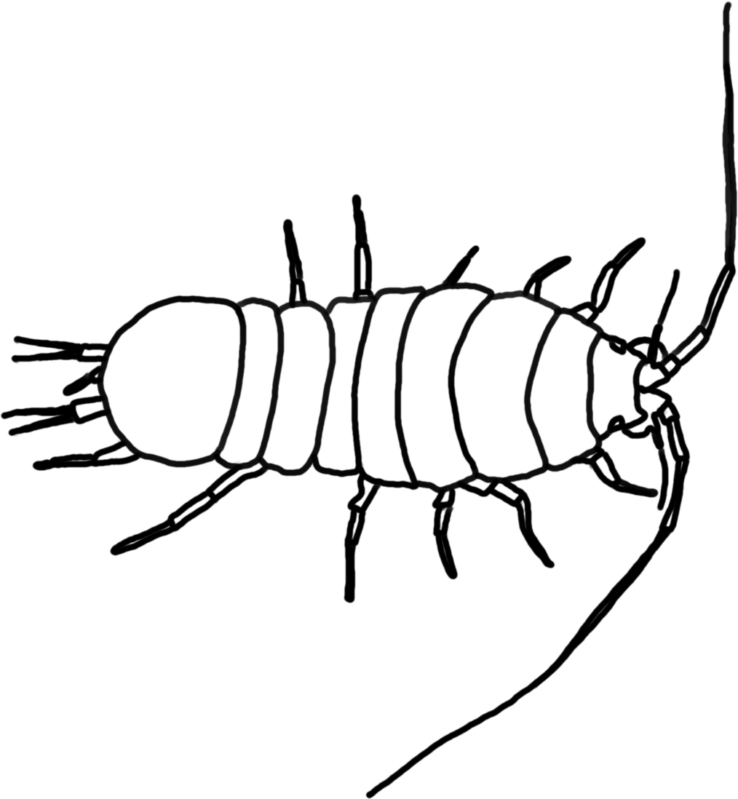
Crayfish (Order Decapoda)- omnivores, primary food is decaying vegetation but will eat anything they can subdue; they are predators and collectors (scavengers). Lives in water with 4.1-7.9 mg/L of dissolved oxygen.
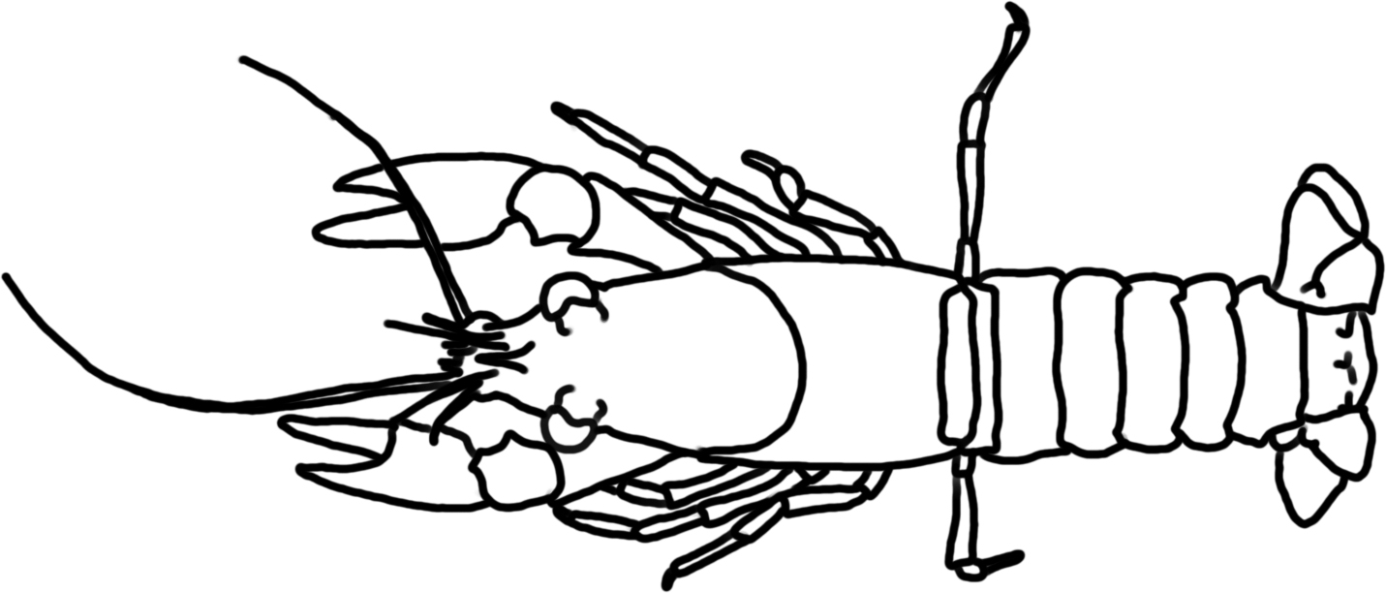

Spiders (Class Arachnids) - Feed by sucking the body fluids from their prey; predators.
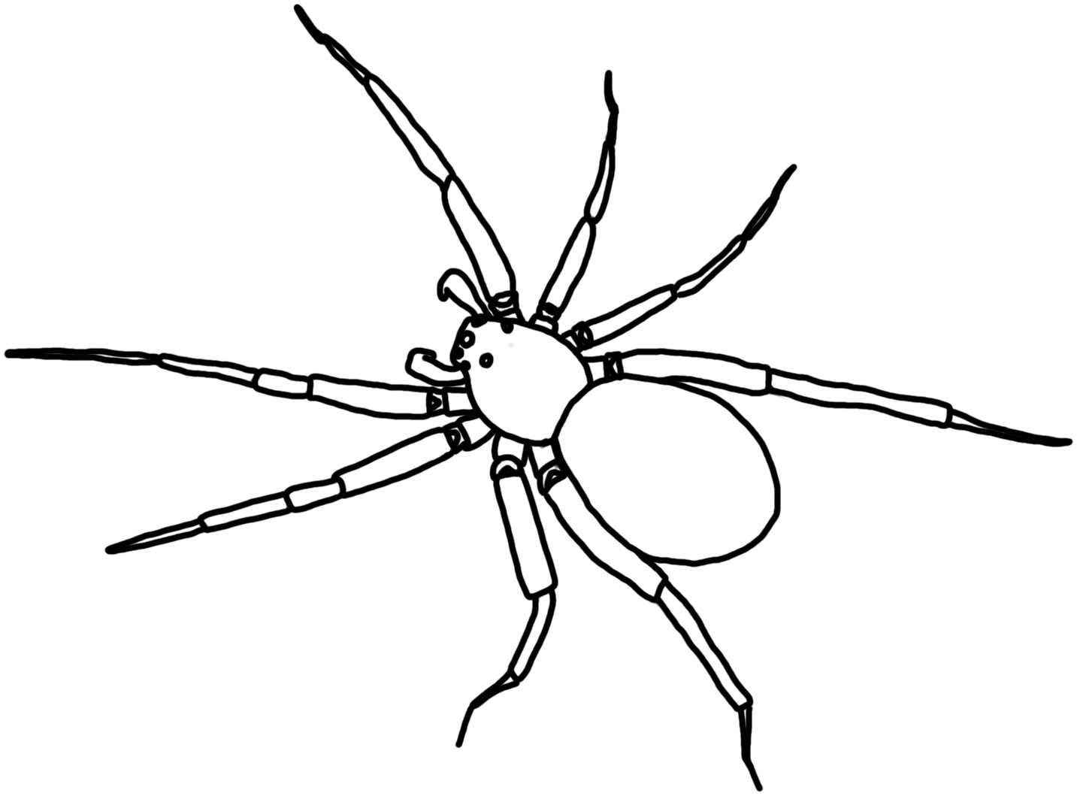
Snails (Class Gastropoda) – Snails scrape algae and other organic matter from ponds substrates. Most snails are scrapers. Gilled snails live in water with 8-12 mg/L of dissolved oxygen, lunged snails can live in water with less than 4 ml/L of dissolved oxygen.
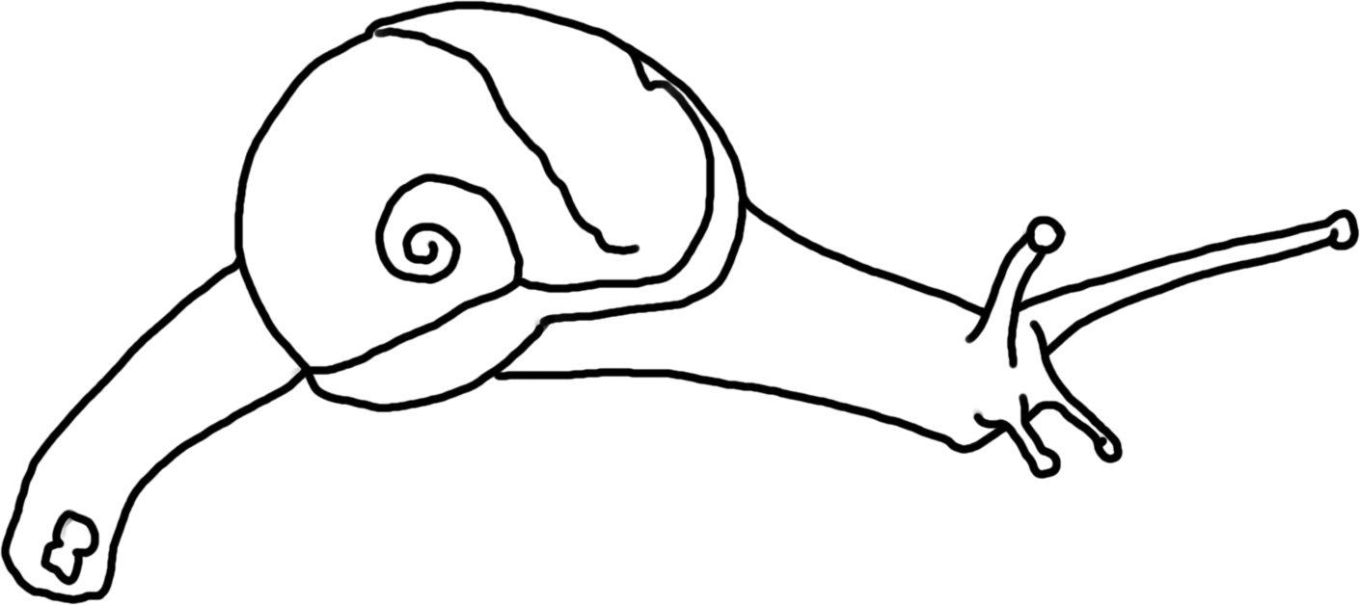
Clams and mussels (Class Bivalvia) – Clams & mussels are filter feeders that live on phytoplankton, zooplankton, detritus and bacteria. They are collectors. Lives in water with 4.1-7.9 mg/L of dissolved oxygen.
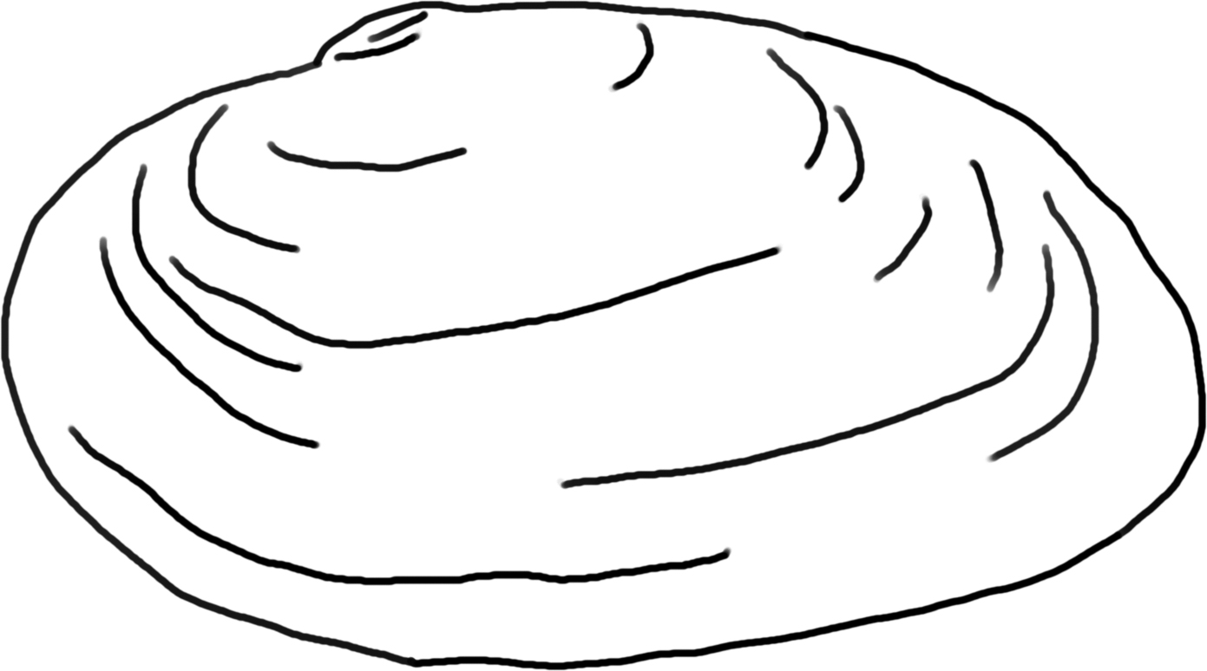

Leeches (Subclass Hirudinea) – Worm-like, soft-bodied organisms with not legs and suckers at either end of the body that attach to hosts and suck fluids from other animals. They are predators (or parasites). Lives in water with less than 4.0 mg/L of dissolved oxygen.

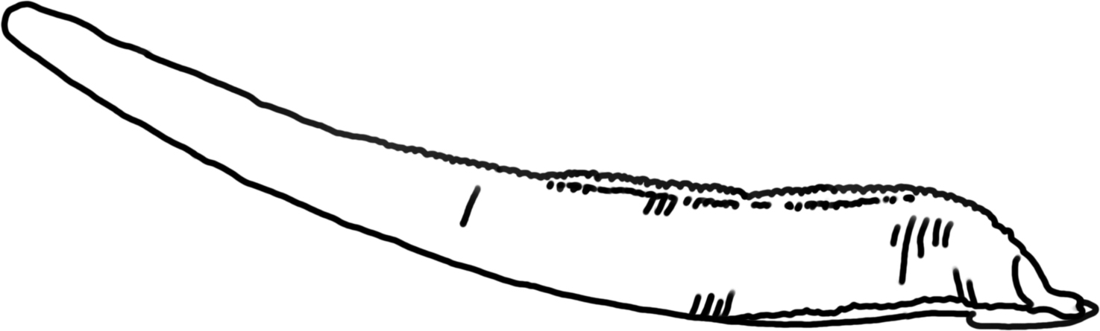

Aquatic Earthworms (Order Oligochaeta) – Most eat detritus, algae and bacteria; these are collectors. Lives in water with less than 4.0 mg/L of dissolved oxygen.
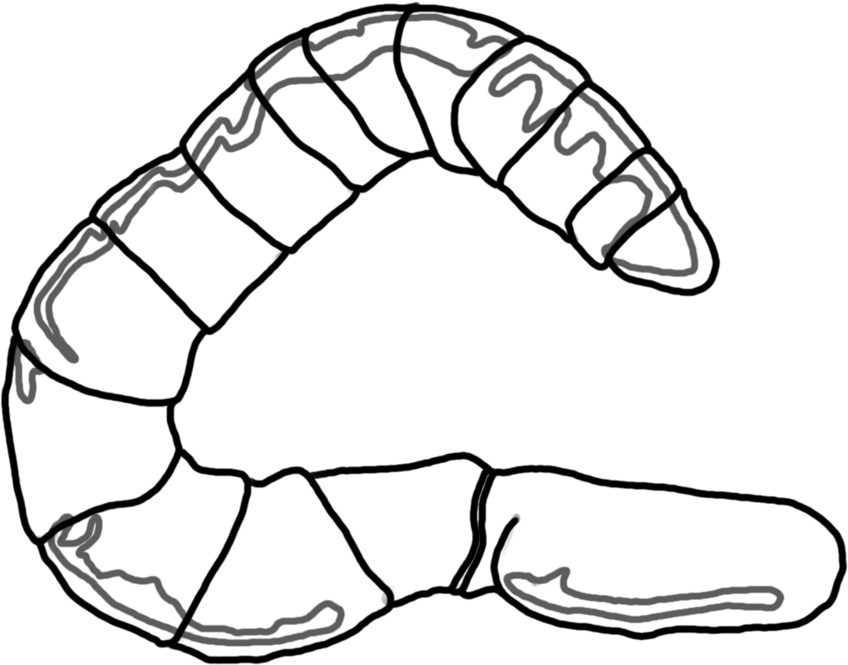
Planaria (Class Turbellaria)- Also called flatworms; predators of soft-bodied invertebrates.

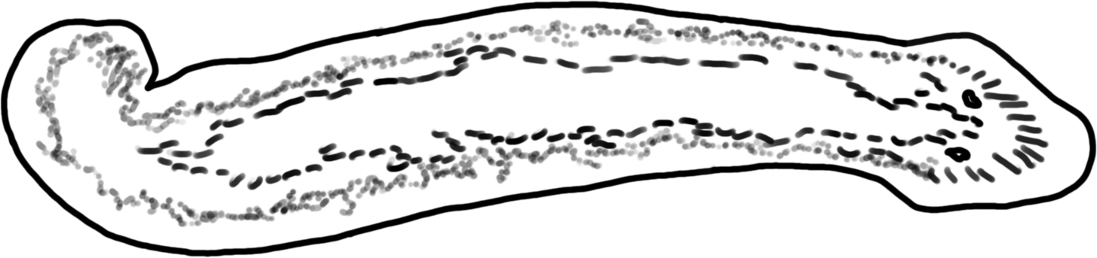

Water mite (Subclass Acari) – These small, tick-like animals live on land and in water. They are parasites or predators of other organisms.
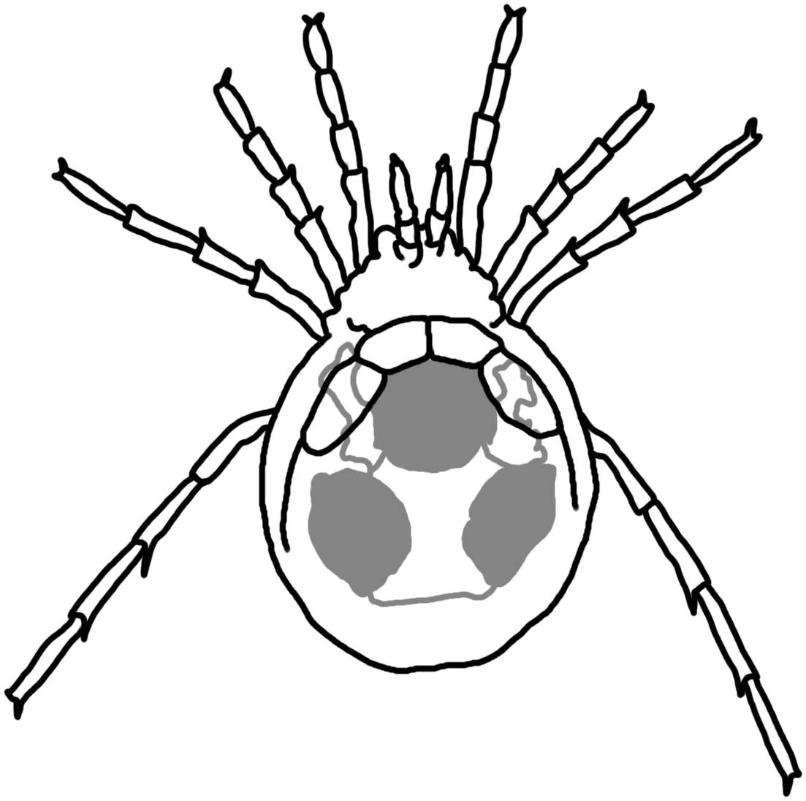
Small arthropods and other protists: mostly consumers (omnivores) that eat small arthropods, protists, bits of detritus, algae etc.

References:
Voshell, J.R. 2002. A Guide to Common Freshwater Invertebrates of North America. McDonald &
Woodward Publishing Company, Virginia.
Thorp, J.H. & A.P. Covich. 2010. Ecology and Classification of North American Freshwater
Invertebrates. Elsevier, Amsterdam.

