Name: _________________________________ Date: ________
Lesson 3: Who Decomposed Our Leaves?

Background: Plants convert the carbon in atmospheric carbon dioxide into carbon-containing organic compounds, such as sugars, fats, and proteins. They combine atmospheric carbon with water and manufacture organic compounds, using energy trapped from sunlight in a process called photosynthesis.
Animals that eat plants, or that eat other animals, incorporate the carbon in the sugars, fats, and proteins derived from the ingested biomass into their bodies. Inside their cells, energy is extracted from the food in a process called cellular respiration. Cellular respiration requires oxygen (which is the by-product of photosynthesis) and it produces carbon dioxide, which is used in photosynthesis. In this way, photosynthesis and cellular respiration are linked in the carbon cycle.
Another way that cellular respiration releases carbon into the atmosphere is through the actions of decomposers. Decomposers, which include bacteria and fungi, derive their nutrients by feeding on the remains of plants and animals. The bacteria and fungi use cellular respiration to extract the energy contained in the chemical bonds of the decomposing organic matter, and so release carbon dioxide into the atmosphere. Here is a diagram that might help:
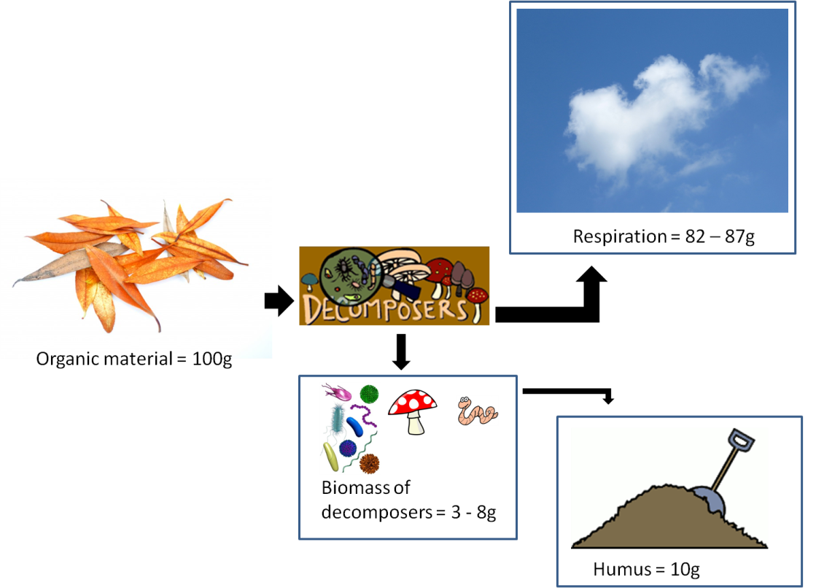
In some ecosystems, such as tropical rainforests, decomposition is accomplished quickly, and carbon dioxide is returned to the atmosphere at a relatively fast rate. In other ecosystems, such as northern forests and tundra, decomposition proceeds more slowly. In some places, such as bogs and the deep ocean, the organic matter of plants and animals may accumulate in deep sediments, where decomposers cannot function well because of the lack of oxygen. Slowly, over millions of years, the carbon-rich materials are converted into carbon-rich fossil fuels, such as petroleum, natural gas, and coal. Also in marine environments, carbon-containing matter (such as calcium carbonate) is incorporated into the shells and other hard parts of aquatic organisms. When these organisms die, the carbon-rich hard parts sink to the ocean bed. There they become buried in sediment, and eventually densify into rocks such as limestone and dolomite.
Before you begin your experiment, write a hypothesis about which tree species you expect to have the most bacteria and/or fungi.
Hypothesis:

Procedure:
Day 1 – Setting up your petri dishes:
- Using a hole punch, punch out 4 pieces of a leaf that you are studying.
- Using forceps carefully place the pieces on a new broth filled petri dish.
DO NOT BREATHE ON OR TOUCH THE PETRI DISH AS THIS COULD CONTAMINATE YOUR DISH.
- Close the petri dish and allow the leaf pieces to sit undisturbed for approximately 30 minutes.
- Using the forceps, carefully remove the pieces of leaf and recover the petri dish.
- Label your petri dish with your name and plant species. Be careful to not obscure the field of view for later observation. Place your dish in a safe place where it will remain undisturbed for several days.
- You may check on your dish every day to see if any colonies have grown. Once you see colonies, notify your teacher.

Day 2 – Measuring bacterial and fungal colonies
- Carefully move your covered petri dish to the lab table. DO NOT REMOVE THE COVER TO PREVENT BACTERIAL AND MOLD COLONIES FROM ESCAPING.
- Draw, color and label a picture of what you see in the circle on the next page.
- Carefully place the graph overlay on the top of your petri dish and take a picture with your Smart Phone.
  - Decide whether you are going to count partial boxes or not!
  - Count the total number of boxes that your petri dish takes up
  - Count the total number of boxes that your bacterial colonies take up. Calculate the % cover = total boxes of bacteria / total boxes.
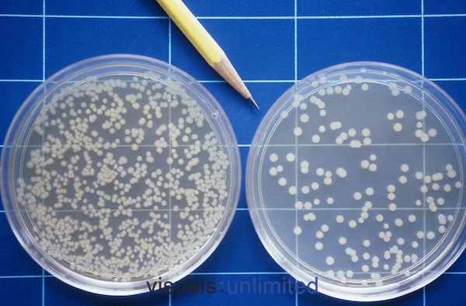

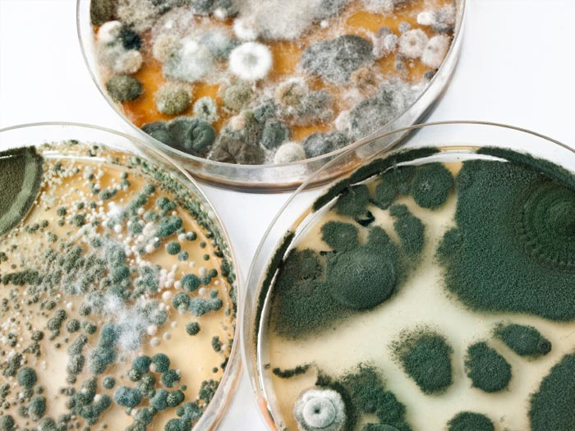
  - Count the total number of boxes that your fungal colonies take up. Calculate the % cover = total boxes of fungi / total boxes.

- Send copies of this image to your lab group so that each person in your group has the opportunity to count the colonies.
- Average your group data and share with the class.
Bacterial and Fungal Colonies in _______________________.
Table 1: Average % Cover Bacterial & Fungal Colonies in _ _______________.
Group Member | Bacterial | Fungal
Average (# boxes with bacteria or fungi/total number of boxes)

Table 2: A Comparison of Average % Cover of Decomposers Found on Different Plant Species.
Tree Species | Average % Bacterial | Average % Fungal
Analysis Questions:
1. Create a bar graph using your class data to compare the average % cover for decomposers.
a. Create a title for your graph
b. Label your axis including units
c. Under your graph, write a one paragraph analysis of the graph describing any trends that you see.
2. Which tree species had the most bacterial cover? Which had the most fungal?

- Explain why you think there might be differences between tree species and amount of fungi and bacteria.

- Compare the class % cover data to the rate of decomposition data for the tree species your class studied during this unit. What connections are there between what decomposers are present and how fast the leaf litter decomposes?

